MESSY FOOD WASTE PREDICTION PROJECT-Summary Report
- Project Objective
The aim of this project is to analyze and predict food waste quantities using various operational and environmental features. The dataset includes information such as meals served, temperature, humidity, staff experience, and special event.
- Data Overview
- Dataset size: Train and test datasets provided separately
- Key columns:
- Date, meals served, temperature, humidity, staff experience,
- Special event, waste category, past waste, food waste (target).

- Data Cleaning and Preprocessing
Steps performed:
- Handled missing values and replaced inconsistent entries such as “MEAt”,” meat”, etc.
- Detected and treated outliers:
- Dropped outliers in temperature (21 rows).
- Replaced extreme values in meals_served (>500) with the column mean.
- Standardized categorical entries (staff_experience, waste_category, etc.).
- Encoded categorical columns using LabelEncoder.
- Created new features:
- Meals_per_staff = meals_served / kitchen_staff.
- Humidity_tem_interaction = humidity * temperature
- Month, is_weekend which were gotten by collapsing the date column.
- Exploratory Data Analysis
  - Correlation analysis
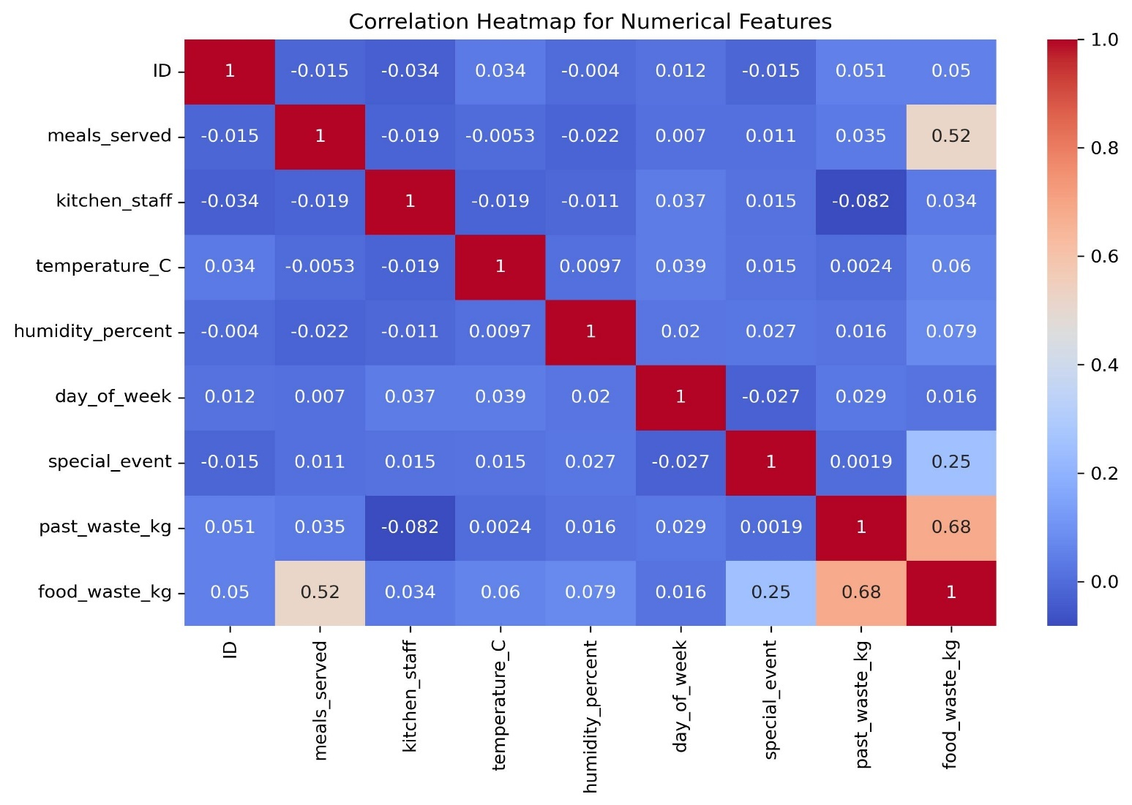
- Strongest positive correlation between past_waste and food_waste, confirming waste history derives future waste.
- Moderate correlation between meals_servd and food_waste.
- Weak or negligible correlation other features.
  - Trend Analysis
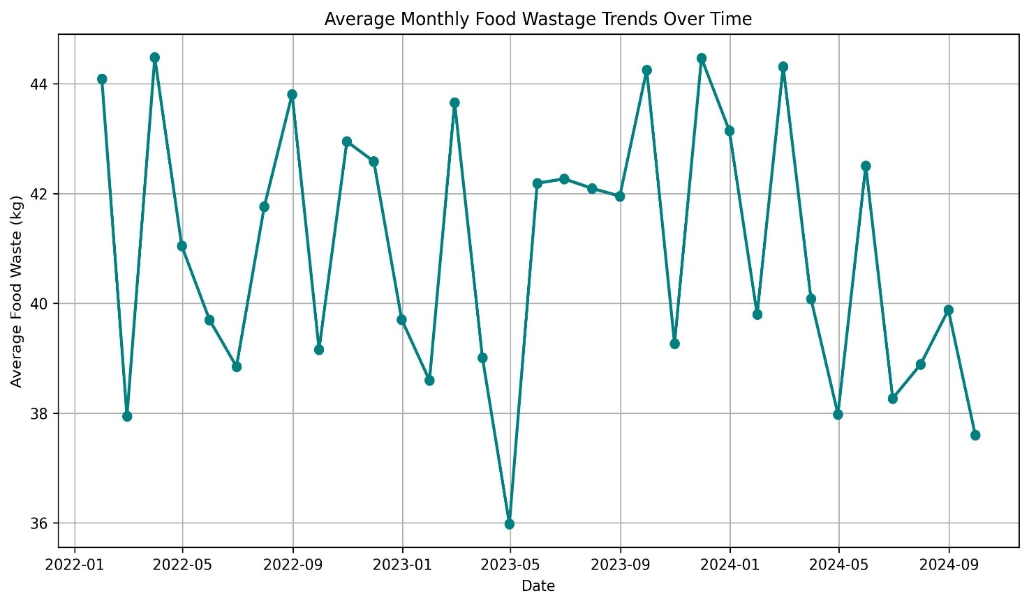
- Lowest waste: around May 2023
- Highest waste: fluctuated, no single clear peak period.
- Average weekly waste: Highest on Sundays, followed by Mondays, least on Fridays.
  - Pairplot Insights
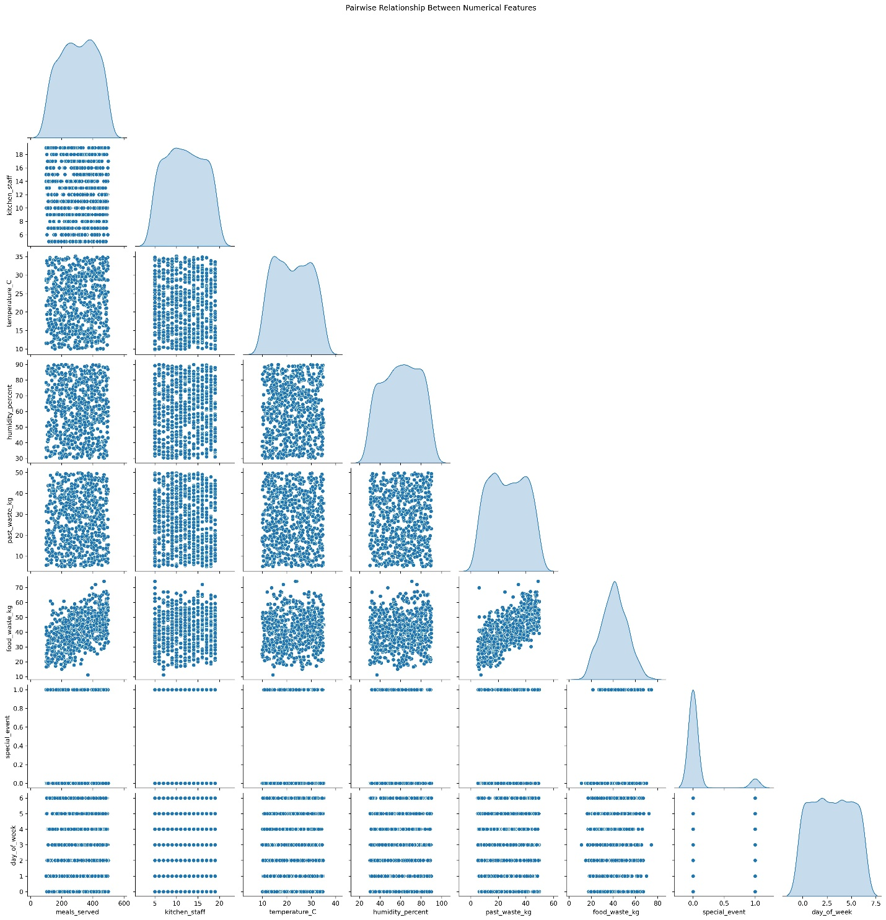
Individual features show weak correlation with waste, but combining operational factors (e.g., meals_served + special_event + humidity) amplify waste generation.
- Feature Engineering
Created and encoded new relevant features:
- Meals_per_staff
- Dayofweek, month, year, is_weekend
- LabelEncoder to encode waste_category and staff_experience
This improved the dataset for model interpretability and predictive accuracy
- Machine Learning
Trained and compared the following models:
- Linear Regression
- Random Forest Regressor (Performed best)
- Gradient Boosting Regressor
Model | R2 Score | RMSE | Remarks
Linear Regression | Low | High | Weak linear fit
Random Forest Regressor | Highest | Lowest | Best generalization and prediction
Gradient Boosting Regressor | Moderate | Moderate | Good but not the best

- Feature Importance (From Random Forest Regressor)

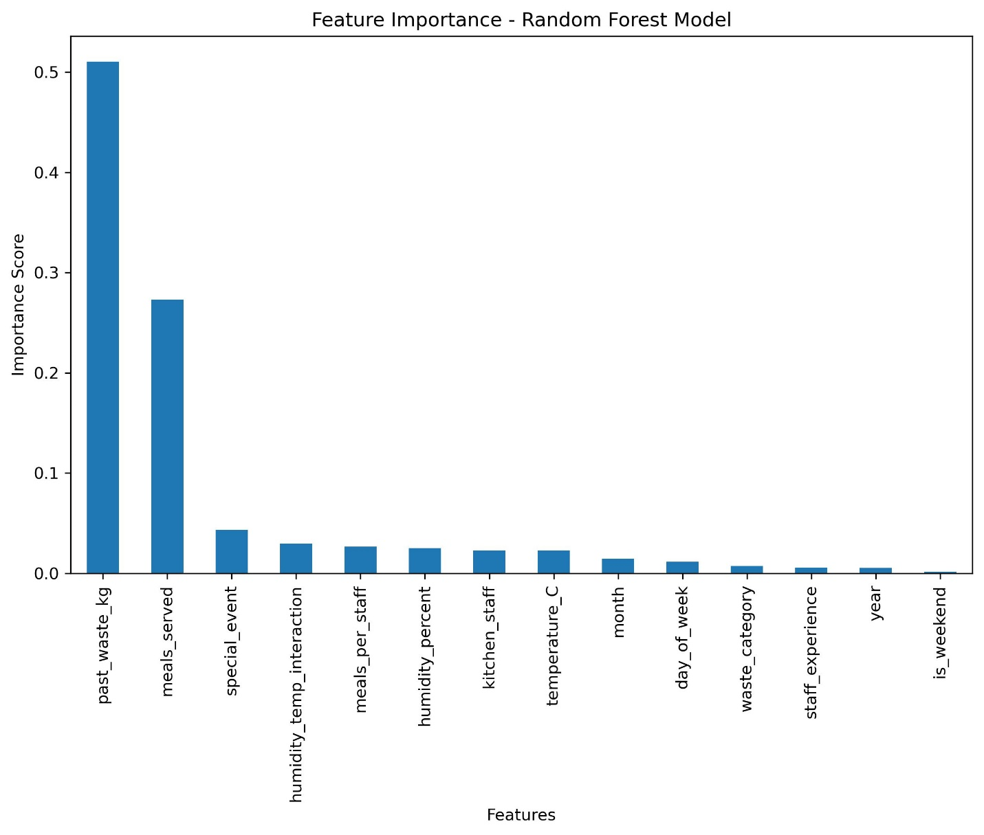
Rank | Feature | Importance | Interpretation
1 | Past Waste (kg) | Highest | Historical waste strongly influences future waste levels, showing clear dependency on past patterns.
2 | Meals Served | High | More meals served typically leads to more waste reflecting volume impact.
3 | Special Event | Moderate | Events (e.g., celebrations, holidays) tends to increase food waste due to over-preparation.
4 | Humidity (%) | Moderate | Humidity may affect food freshness and storage, indirectly influencing waste
5 | Temperature (C) | Moderate | Higher or lower temperatures may lead to spoilage or changes in meal patterns.
6 | Meals Per Staff | Slight | Staff efficiency influences how well meals are portioned or handled.
7 | Month / Day of Week | Slight | Some seasonal or weekly patterns exist in food trends.
8 | Waste Category | Low | Specific waste categories (organic, leftover, etc.) show smaller variation in impact.
9 | Staff Experience | Low | Experience plays a minor role but may still influence handling efficiency.
10 | Year | Low | Minimal long-term drift across years.
11 | Weekend | Lowest | Weekends influence is minimal compared to other operational features.

- Insight and Recommendations
- Past waste patterns are key predictors - historical monitoring is essential.
- Meal volume and special events strongly influence waste – better planning and forecasting are required.
- Environmental factors (humidity, temperature) also affect spoilage rates.
- Encourage experience-based staff training to reduce inefficiencies.

